**Eyratech website integration with Strapi**

This documentation outlines the migration from static content to dynamic CMS-driven implementations using Strapi. Key updates include: dynamic SEO management (meta titles, descriptions, keywords, and OpenGraph data).Use dynamic data for Carousel and dynamic card for Industries, Services, and Technologies sections on the Homepage. Dynamic all the sections for the About Page. All content and media are now centrally managed through Strapi’s admin panel, enabling real-time updates without code changes.

**Content Types on Admin Panel**

**COLLECTIONS**

1. Hero Section
2. About Section
3. Industries Section
4. Services Section
5. Technologies Section
6. Contact Section
7. Footer Section
8. About Hero
9. Partner Choice
10. About Story

**SINGLE TYPES**

1. Home Meta
2. About Meta

**COMPONENTS**

* *Common*  
  Section-header
* *Elements*  
  Card  
  Form  
  Input  
  Offices Card  
  Primary Button  
  Services Title  
  Tech Card  
  Technology
* *Texts*  
  Footer Steps
* *Seo*  
  Meta Data

**Project Structure**

* **EYRATECH-STRAPI-INTEGRATION**  
   - eyratech-website-v2 (Frontend application)  
   - eyratech-strapi (Strapi application)

**Environment Variable for strapi application**  
*eyratech-website-v2/. env*

NEXT_PUBLIC_STRAPI_API_URL=http://localhost:1337

**Function that takes an API endpoint path and designed to fetch data from Strapi (CMS)**

*eyratech-website-v2/src/api.js*

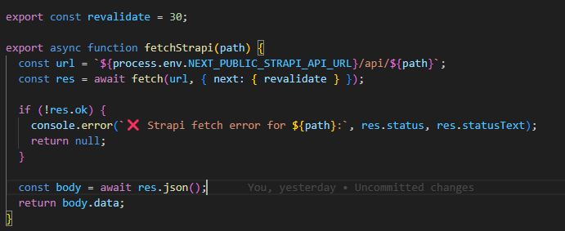

**export const revalidate = 30;**

**export async function fetchStrapi(path) {**

**const url = `${process.env.NEXT_PUBLIC_STRAPI_API_URL}/api/${path}`;**

**const res = await fetch(url, { next: { revalidate } });**

**if (!res.ok) {**

**console.error(`❌ Strapi fetch error for ${path}:`, res.status, res.statusText);**

**return null;**

**}**

**const body = await res.json();**

**return body.data;**

**}**

**Home Page**

**Home page APIs endpoints**

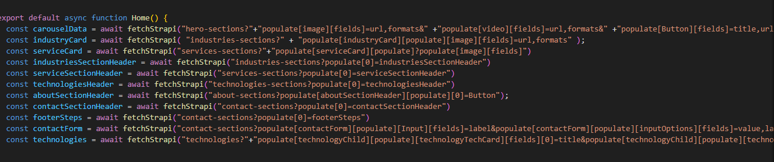

**Home Page Metadata Implementation**

The Home page’s SEO elements were converted from static values to dynamic fields using Strapi’s Single Type "Home Meta". This contains a "homeMetaData" component.

**Home Meta (Single Type)**

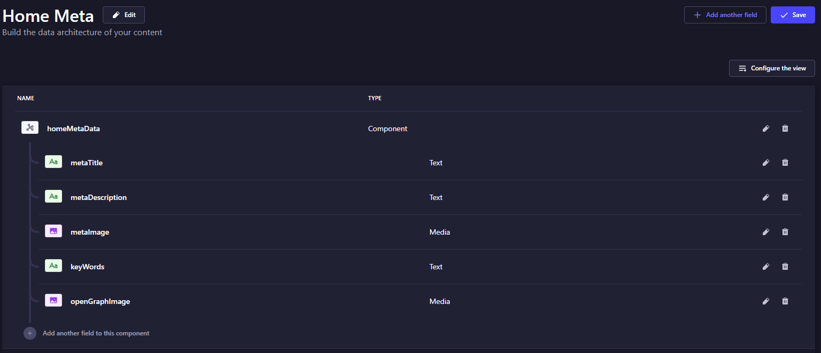

**Frontend Changes.  
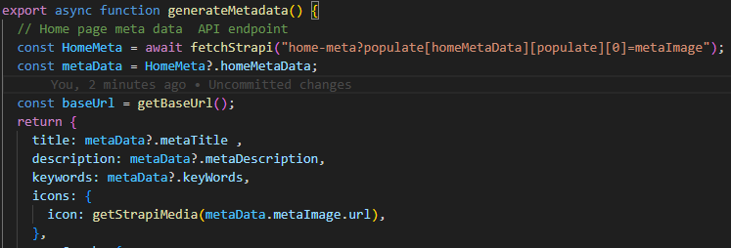**

**Hero Section Carousel**

The Hero section carousel converted to a dynamic carousel using Strapi’s Collection Type "Hero Section". Each carousel includes Text fields, Number field, Media fields and Button Component.

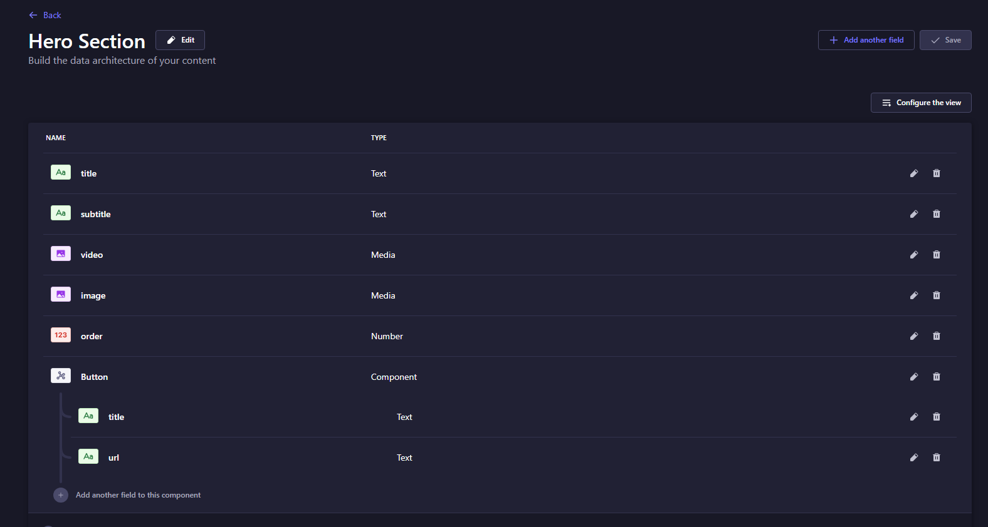

**About Section**

This dynamic about section is using Strapi’s Collection Type "About Section". This collection includes a Media field, component ‘aboutSectionHeader’ and another component ‘Button’.

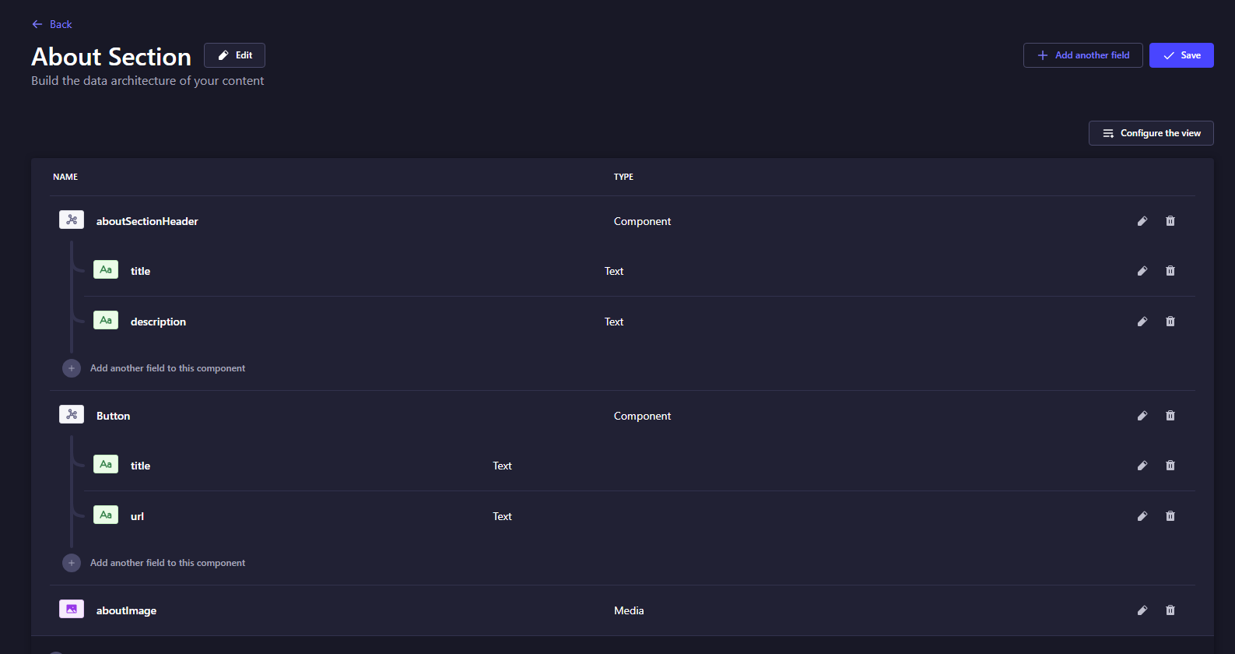

**Industries Section**

Dynamic industries section is using Strapi’s Collection Type "Industries Section" includes two components Section Header named ‘industriesSectionHeader’ and Card named ‘industryCard’.

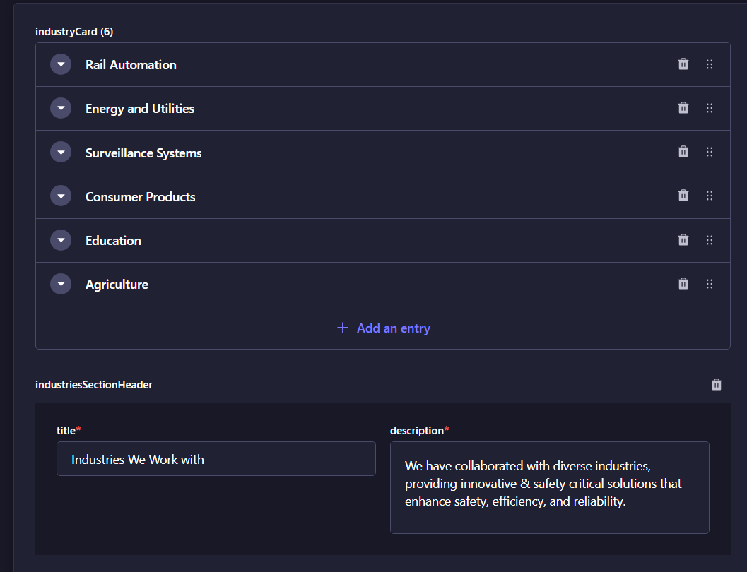

**Services Section**

Dynamic industries section is using Strapi’s Collection Type "Services Section" includes two components Section-header named ‘servicesSectionHeader’ and Card named ‘serviceCard’.

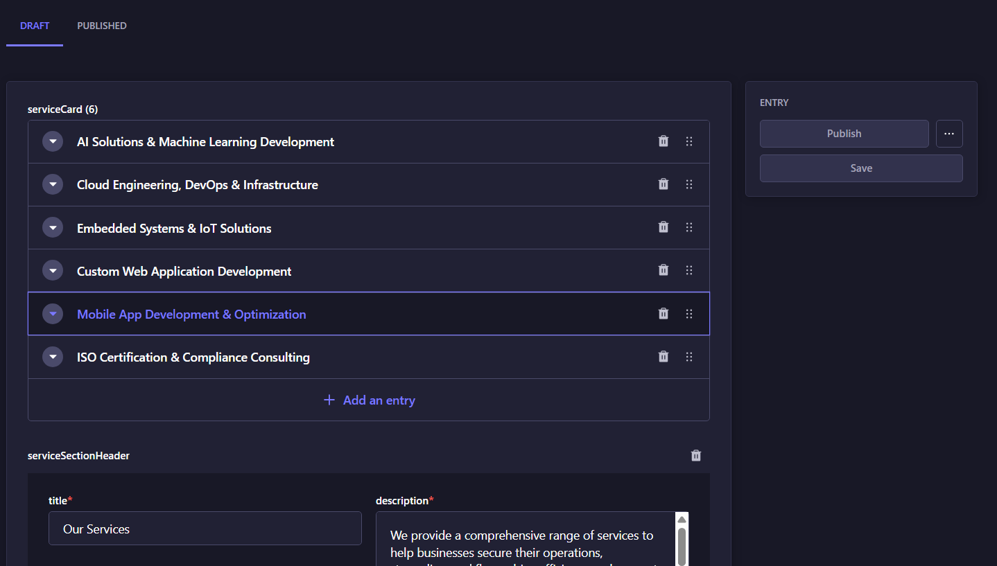

**Technologies Section**

Dynamic technologies section is using Strapi’s Collection Type "Technologies Section" contain one component Section Header named ‘technologiesHeader’

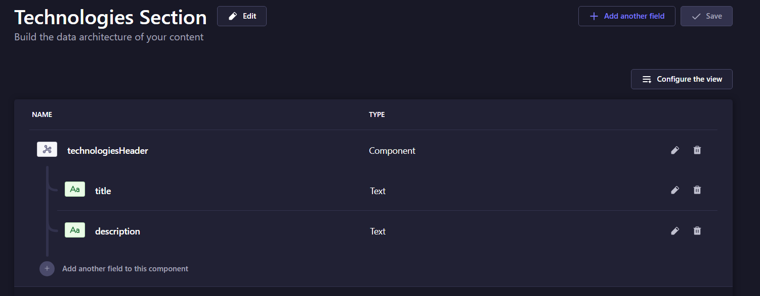

**Technologies Section**

Dynamic technologies Section is also using Strapi’s Collection Type "Technology Section" contain one nested repeatable component ‘technologiesChild’. TechnologyChild component further contain a repeatable component ‘technologyTechCard’.

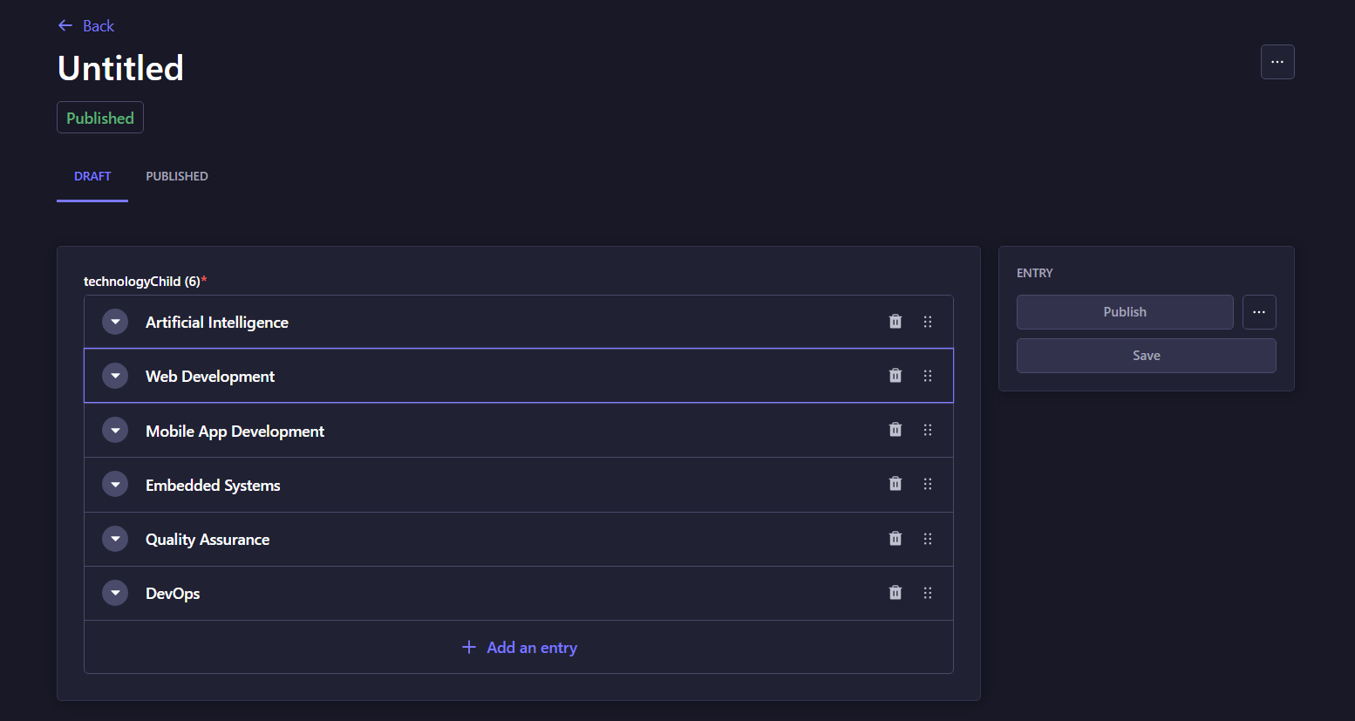

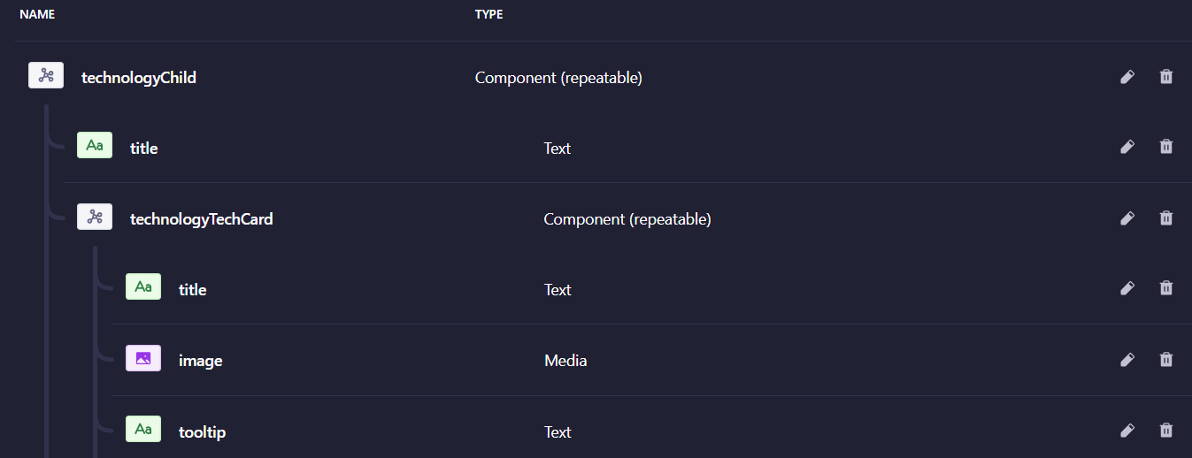

**Contact Section**

Dynamic Contact section is using Strapi’s Collection Type "Contact Section" contain the following components.

* contactSectionHeader
* footerSteps
* contactForm (Contain three components Input, inputOptions and serviceTitles)

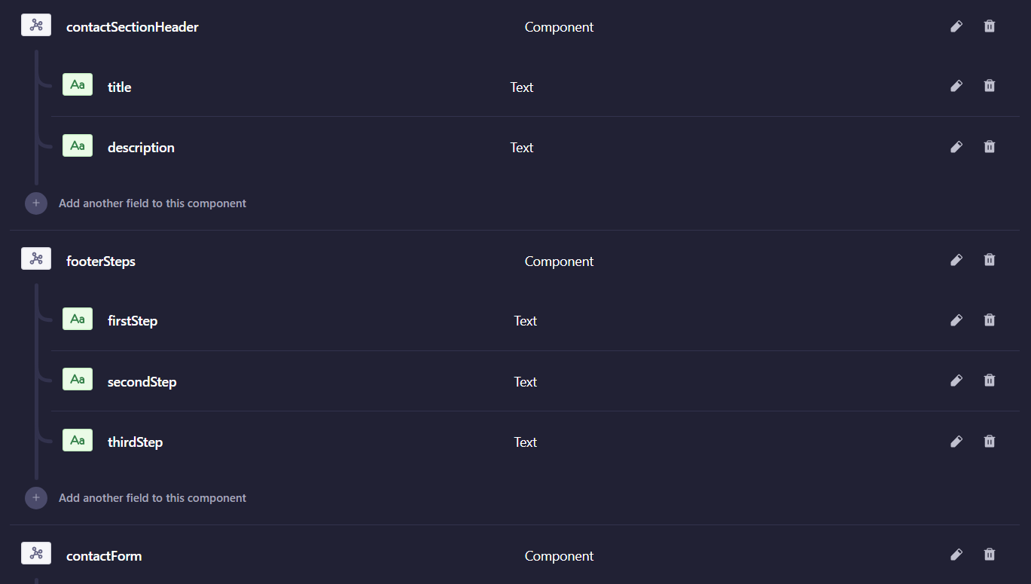

**Footer**

Dynamic Footer section is using Strapi’s Collection Type "Footer Section" contain a single repeatable component ‘officesCard’

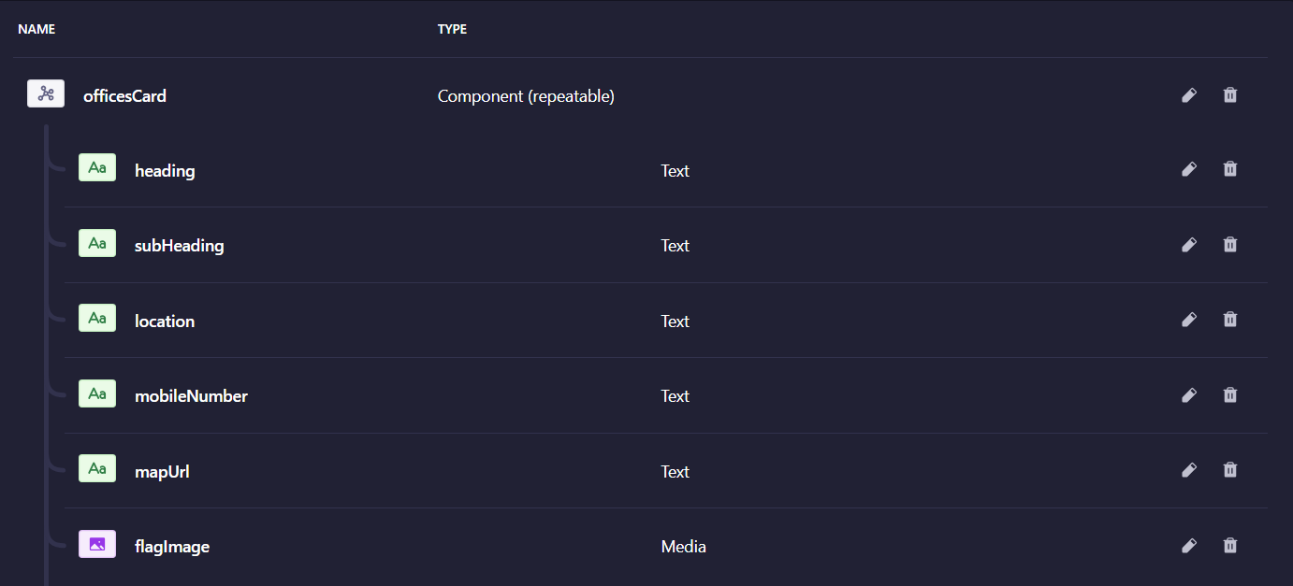

**Content Types for Home Page**

|  |  |  |
| --- | --- | --- |
| Collections | Collection Fields | Collection Components |
| Home Meta (Single Type) |  | homeMetaData |
| About Meta (Single Type) |  | aboutMetaData |
| Hero Section | title, subTitle, video, image, order | Button |
| About Section | aboutImage | aboutSectionHeader, Button |
| Industries Section |  | industryCard(repeatable), industriesSectionHeader |
| Services Section |  | serviceCard(repeatable), serviceSectionHeader |
| Technologies Section |  | technologiesHeader |
| Technology |  | technologyChild (repeatable) |
| Footer Section |  | officesCard(repeatable) |

**About Page**

**endpoints**

**About Page APIs endpoints**

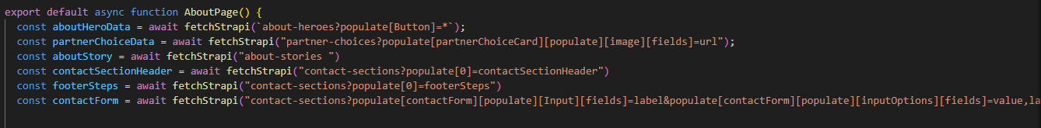

**About Hero Section**

This section is using the AboutHero section of strapi. AboutHero collection contains two (text) fields and two components (Button, styledText).

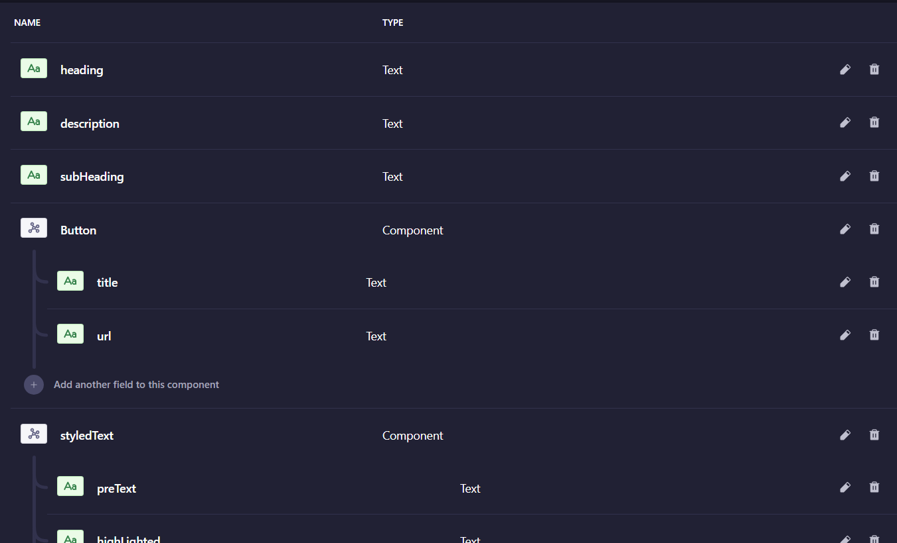



**Partner Choice Section:**

Partner choice section is using the Partner Choice collection from starpi which includes the partnerChoiceCard (repeatable component) component and heading (text) field.

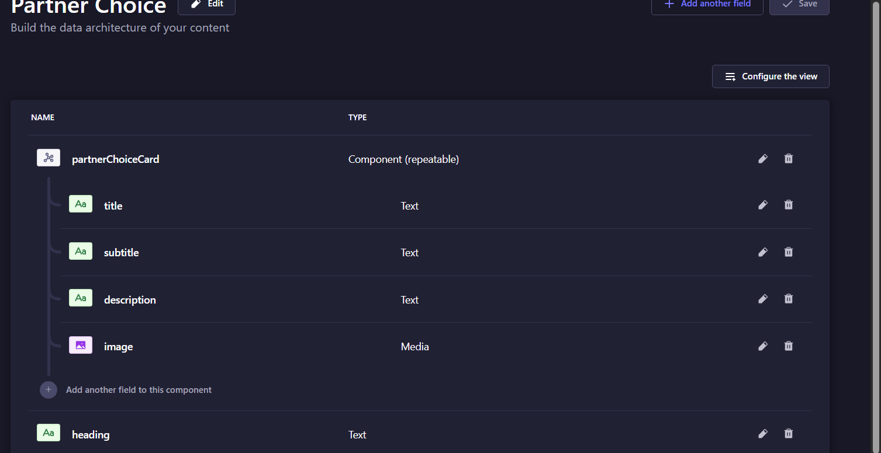

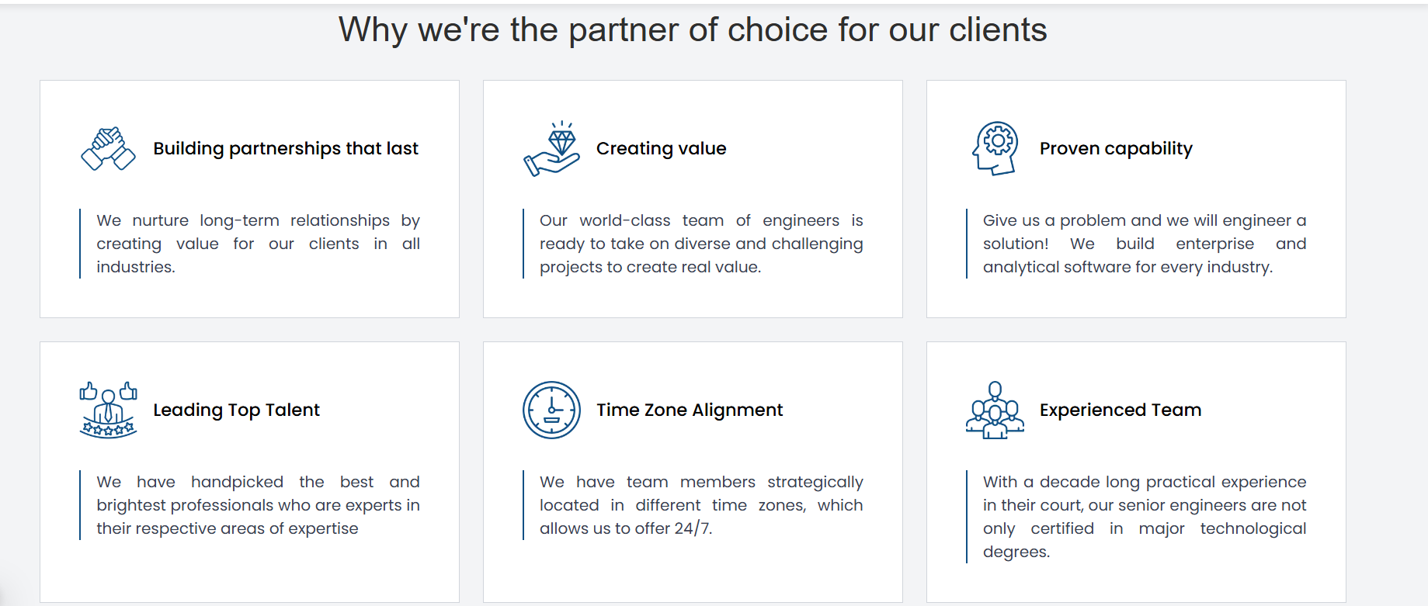

**Our Story:**

Integrated with the ‘About Story’ collection, contains text fields.   
